Project Planning Phase
(Product Backlog, Sprint Planning, Stories, Story points)

Date | 21 October 2022
Team ID
Project Name | Deep Learning Fundus Image Analysis for Early Detection of
 | Diabetic Retinopathy.
Maximum Marks | 8 Marks

Product Backlog, Sprint Schedule, and Estimation (4 Marks)

To create product backlog and sprint schedule.

Sprint | Functional | User Story | User Story / Task | Story Points | Priority | Team Members
 | Requirement (Epic) | Number
Sprint-1 | Registration | USN-1 | As a user, I can register for the application | 10 | High | Naveen S
 |  |  | by entering my email or phone number
 |  |  | and password, and confirming my
 |  |  | password.
Sprint-1 | Dashboard | USN-2 | As a user, I will Redirect to the dashboard | 10 | Medium
 |  |  | after registration which shows the |  |  | Sundarakalathi K
 |  |  | importance of DR. |  |  | &
 |  |  |  |  |  | Syed Abuthair A
Sprint-2 | Login | USN-3 | As a user, I can log into the application by | 5 | High
 |  |  | entering Login credentials. |  |  | Naveen S
Sprint-2 | Upload Images | USN-4 | As a user, I should be able to upload the image | 10 | High
 |  |  | of eye Retina. |  |  | Karthick M

Sprint-2 | Dashboard | USN-5 | As a user, based on my requirement I can | 5 | Medium
 |  |  | navigate through the dashboard. |  |  | Syed Abuthair A
Sprint-3 | Train the model | Task 1 | As a developer, the dataset will be uploaded | 20 | High
 |  |  | and trained by developed algorithm. |  |  | Sundarakalathi K
Sprint-4 | Testing & Evaluation | Task 2 | As a developer, we tested the trained model | 10 | High
 |  |  | using the provided dataset and model will be |  |  | Naveen S
 |  |  | evaluated for accurate results.
Sprint-4 | Display | USN-6 | As a user, I can view the predicted result in | 10 | High
 | predicted |  | the dashboard. |  |  | Karthick M
 | result

Project Tracker, Velocity & Burndown Chart: (4 Marks)

Sprint | Total | Duration | Sprint | Sprint | Story Points | Sprint Release
 | story |  | Start | End Date | Completed (as | Date(Actual)
 | point |  | Date | (Planned) | on Planned
 |  |  |  |  | End Date)
Sprint-1 | 20 | 6 Days | 24 Oct 2022 | 29 Oct 2022 | 20 | 29 Oct 2022
Sprint-2 | 20 | 6 Days | 31 Oct 2022 | 05 Nov 2022 | 20 | 05 Nov 2022
Sprint-3 | 20 | 6 Days | 07 Nov 2022 | 12 Nov 2022 | 20 | 12 Nov 2022
Sprint-4 | 20 | 6 Days | 14 Nov 2022 | 19 Nov 2022 | 20 | 19 Nov 2022

Velocity:

Imagine we have a 10-day sprint duration, and the velocity of the team is 20 (points per sprint). Let’s calculate the team’s average velocity (AV)per iteration unit (story points per day).
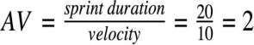

AV=20/6=3.33points per day.
Burn Down Chart & JIRA :

A burn down chart plots the amount of work remaining to perform against the amount of time. In agile software development approaches like Scrum, it is frequently employed. Burn down charts, however, can be used for any project that makes observable progress over time.
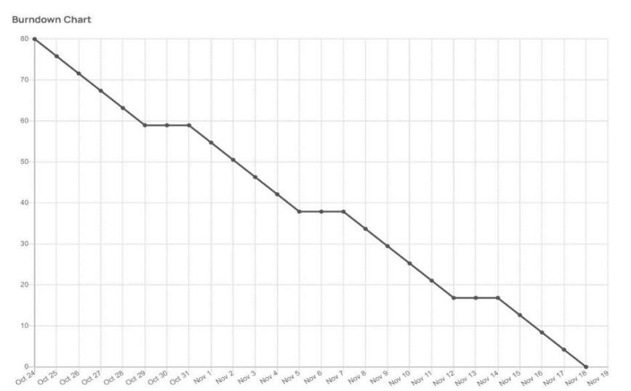

JIRA Folder is created to show the Scrum methodologies and Burn Down chart progress.

